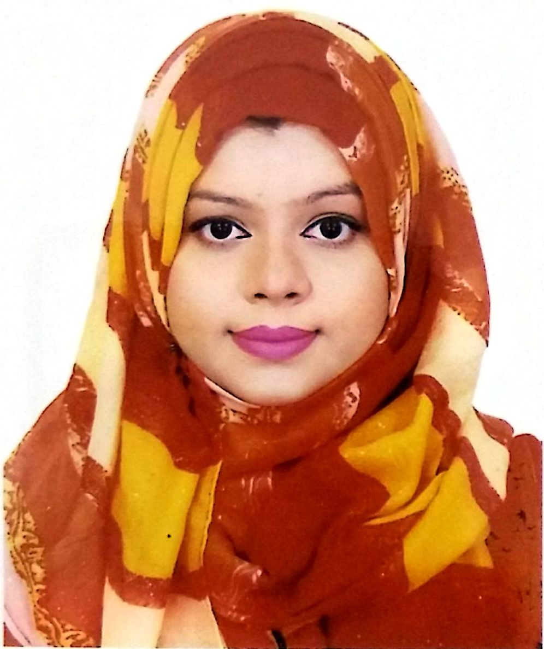

Tasmia Rahman

Eastern Monjil, Flat#403
8/5 Aurangajeb Road,
Mohammadpur, Dhaka-1207
Email: tasmia0911@gmail.com
Cell: 01703561088

Objectives:

To get a position in an emerging and challenging organization, where I will have the scope to utilize my potentiality, adaptability and skill to do something innovative being in the midst of a strong cultural environment of accepting, sharing and rewarding better ideas and strengthen my future professional career as well as serve the organization to achieve their aims and goals with prudence, sincerity, honesty and efficiency.

Skills:

- Programming Language: JAVA
- Software: MATLAB, Net Beans, Eclipse
- Image Processing experience in OpenGL, JOGL
- PHP, HTML, CSS, JavaScript
- Database: MySQL
- Web Development Frameworks: Laravel

Projects:

- Web based Student Management and Course Enrolment System
- Online Bakery Shop and Blog Website using Laravel

- Social Networking Website (Reddit Clone)
- System Workflow, Design and Analysis of an Army Inventory Software
- YouTube Tutorial Storage as per user’s wish list and prepare to-do list in Android

Areas of Interest:

- Object Oriented Programming
- Application Development
- Web Development
- Web Design

Experiences:

- Worked as a Teaching Assistant in Computer Science department of BRAC University for 2 years.

Achievements:

- General Scholarship in S.S.C
- Dean’s Award and VC’s award

Education:

- Bachelor of Science in Computer Science (January 2012- December-2015)
CGPA 3.74 out of 4.00
BRAC University, Dhaka

- Higher Secondary School Certificate (2009-2011)
CGPA 5.00 out of 5.00
Dhaka City College, Dhaka

- Secondary School Certificate (2008-2009)
CGPA 5.00 out of 5.00
Viqarunnisa Noon School and College, Dhaka

Research and Thesis: A Machine Learning Approach in Predicting the Rainfall Amount and
Crime Category.

Profile:

Date of Birth : 22-03-1994
Gender : Female
Marital Status : Single
Nationality : Bangladeshi
Languages Known : English, Bangla

